### Employee Data Analysis using Excel

**STUDENT NAME: KANISHKA B**

**REGISTER NO: 6C97D859B95AED196BD44ADD16E5F085,312208696**

**DEPARTMENT: B.COM(GENERAL)**

**COLLEGE : MEENAKSHI COLLEGE FOR WOMEN**

1



## PROJECT TITLE

**Employee Performance Analysis based on employee education and dependency of members**

2

# AGENDA

3/21/2024 **Annual Review**



1. Problem Statement
2. Project Overview
3. End Users
4. Our Solution and Proposition
5. Dataset Description
6. Modelling Approach
7. Results and Discussion
8. Conclusion



3

## PROBLEM STATEMENT

Here are the best employee sentiment analysis tools for organizations to get a deep dive into their employees' sentiment. Each of these platforms mentioned below have the sentiment analysis feature, so we'll just keep a brief discussion about each of the platforms.



4

## PROJECT



**OVERVIEW**

An employee sentiment analysis tool is a specialized software that uses natural language processing (NLP) and machine learning to interpret and analyze the emotions expressed in textual data.

This technology is adept at parsing through large volumes of employee feedback, comments, and communications

5

### WHO ARE THE END USERS?

* **HUMAN RESOURCE DEPARTMENTS**
* **MANAGEMENT AND LEADERSHIP**
* **TEAM LEADERS AND SUPERVISORS**
* **EMPLOYEES**
* **EXECUTIVE LEADERSHIP**
* **BUSINESS ANALYSTS**
* **RECRUITERS**

6

**OUR SOLUTION AND ITS VALUE PROPOSITION**



FILTERING- REMOVE VALUES

PIVOT TABLE - SUMMARY OF EMPLOYEE PERFORMANCE

BAR DIAGRAM - FINAL REPOR

7

# Dataset Description

* **EMPLOYEE DATA SET- NAN MUDHALVAN PORTAL**
* **9 FEATURES IN EXCEL:**

**EMPLOYEE ID-** ALPHANUMERIC(TEXT) **NAME-** ALPHABETICAL(TEXT) **GENDER-** ALPHABETICAL(TEXT) **DEPARTMENT -** ALPHABETICAL(TEXT) **SALARY -** NUMERICAL

**START DATE -** ALPHANUMERIC(TEXT)

**FTE-** NUMERICAL

**EMPLOYEE TYPE-** ALPHABETICAL(TEXT)

**EMPLOYEE LOCATION-** ALPHABETICAL(TEXT)

* **3 FEATURES USED:**

**DEPARTMENT -** ALPHABETICAL(TEXT)

**FTE-** NUMERICAL

**EMPLOYEE TYPE-** ALPHABETICAL(TEXT

# THE "WOW" IN OUR SOLUTION



* + **There is a famous story about a naive student in his first English literature course who was worried because he didn't know what prose was**.
    - **When he found out that prose was ordinary speech, he exclaimed, " Wow! I've been speaking prose all my life!** ❖

9

3/21/2024 **Annual Review**

# MODELLING

* **STEP -1**

**DOWNLOAD THE EMPLOYEE DATASET AND OPEN THE EMPLOYEE DATASET IN EXCEL.**

* **STEP -2**

**SELECT THE ENTIRE DATA AND CLICK ON DATA**

**AND CLICK ON FILTER OPTION.**

* **STEP -3**

**FILTER FTP FROM A TO Z ORDER.**

* + **STEP -4**

**SELECT THE ENTIRE DATA AND CLICK ON INSERT AND CLICK ON PIVOT TABLE TO CREATE PIVOT TABLE.**

10

* **STEP -5**

**DRAG THE NEEDED DATA AND CREATE A PIVOT TABLE.**

* **STEP -6**

**SELECT THE PIVOT TABLE AND CLICK ON INSERT.**

* **STEP-7**

**NOW CLICK ON THE CHART THAT YOU WANT.**

* **STEP -8**

**THE CHART IS CREATED**

# RESULTS

12

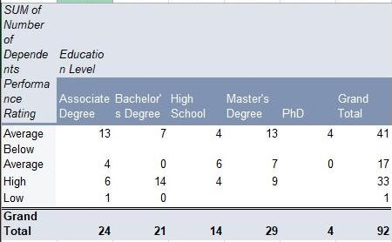

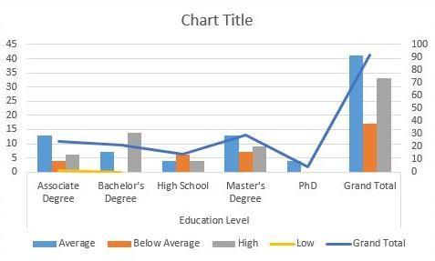

# Conclusion

Employee performance reviews, along are the most valuable tools a good manager can take advantage of to boost employee performance and business results.

But, the value of those reviews is directly related to how

well a manager can deliver a useful and focused review. Theto the work the employee does so the employee understands what is being conveyed to them. The review must stay focused on the work and the workplace, and not run off track.